Team 1-k15t01-Vanlanguni
Master Design Plan
Smart Mart System
Prepared by: Team1-K15T1-Vanlanguni
Version 1.0


Team members
- Le Dinh Thach Huyen (Member)
- Đang Huy Son (Technical Researcher)
- Do Minh Tam (Technical Researcher & Recorder)
- Nguyen Trung Tin (Member)
- Le Thi Bich Van (Project Manager)
Abstract
Smart Mart System is a software provide a sales system in conjunction with its laugh of point service – POS (Point of Sale)
Revision history
Content | Date | Author | Version
Define Schedule | 07/11/2012 | Le Thi Bich Van | Ver0.1
Define template Master Design Plan | 07/13/2012 | Le Dinh Thach Huyen | Ver0.2
Review template and complete template Master Design Plan | 07/15/2012 | Le Thi Bich Van | Ver0.3
Complete Master Design Plan | 07/22/2012 | Le Thi Bich Van | Ver1.0

Table of content
1.1. Purpose 3
1.2. Scope and goal of project 3
1.3. Information of Stakeholder for final project 3
1.3.1. Customer of Final Project 3
1.3.2. The supervisor for Final Project 3
1.3.3. Our team for the project is called Team1-K15T1-Vanlanguni and consist of 3
1.4. Definition and Acronyms 4
1.5. References 4
1.6. Applicable document 4
1.1. The process in architecture design team 4
1.2. Role assignments in the ACDM 5
1.3. ACDM - Architecture Centric Design Method 6
1.3.1. Define and Key goals of ACDM 6
1.3.2. ACDM Stages 7
1.3.3. Using ACDM with Software Development Frameworks – Waterfall 8
4. Requirement Document 8
List of tables
Table 1-Definition and Acronyms 4
Table 2 - Role Assignments in the ACDM 7
List of figures
Figure 1-Team Process 5
Figure 2 - Representation of the relationships among the managing engineer, chief architect, and chief scientist with respect to the project and system/product design 6
Figure 3 - Representation of the relationships among the quality process engineer, requirement engineer, and chief scientist with respect to system/ product test 7
Figure 4 - ACDM Stages 8
Figure 5 - ACDM and the waterfall model 9

- Introduction

Purpose
The Master Design Plan is reviewed at the conclusion of each stage by the quality process engineer to ensure that it is current and of the appropriate quality.
In this document include, establishing an initial schedule is critical to tracking the effort of the architecture design team. This is essential for project tracking.

Scope and goal of project
In SMS Project our team gives a description of the analysis and design of the Smart Mart System at architectural level. Then, implement and demo at least one Use Case “Record sale Transaction”.

Information of Stakeholder for final project

Customer of Final Project
Ms. Huong Nguyen, Lecturer of Van Lang University
Phone:
E–Mail: nguyenthuyhuong@vanlanguni.edu.vn

The supervisor for Final Project
Ms. Hong Phan, Lecturer of Van Lang University
Phone:
E–Mail: mailto:phanthihong@vanlanguni.edu.vn

Our team for the project is called Team1-K15T1-Vanlanguni and consist of

Le Dinh Thach Huyen, Member
Phone: 090.918.8571
E–Mail: mailto:radinkasim@gmail.com
----------------------------------------------------
Dang Huy Son, Technical Researcher
Phone: 0199.8766.424
E–Mail: mailto:slavril.2009@gmail.com
----------------------------------------------------
Do Minh Tam, Technical Researcher & Recorder
Phone: 0126.7322.839
E–Mail: mailto:tamdo4@gmail.com
------------------------------------------------------
Nguyen Trung Tin, Member
Phone: 0128.4317.131
E–Mail: mailto:trungtin119@gmail.com
-----------------------------------------------------
Le Thi Bich Van, Project Manager
Phone: 0985.197.070
E–Mail: vanbichthile@gmail.com, vanle12@vanlanguni.vn

Definition and Acronyms
No. | Term | Definition
1. | ADsD | Architecture Drivers Document
2. | ADD | Architecture Design Document
3. | SMS | Smart Mart System
4. | POS | Point of Sale
Table 1-Definition and Acronyms

References
Architecting_Software_Intensive_Systems-a_Practitioners_Guide_Anthony_Lattenze08_Nov.2008.eBook-DDU

Applicable document
K15T1-Team1-SmartMartSystem-ScheduleRework-2007
- General statement of Design Architecture SMS project

The process in architecture design team
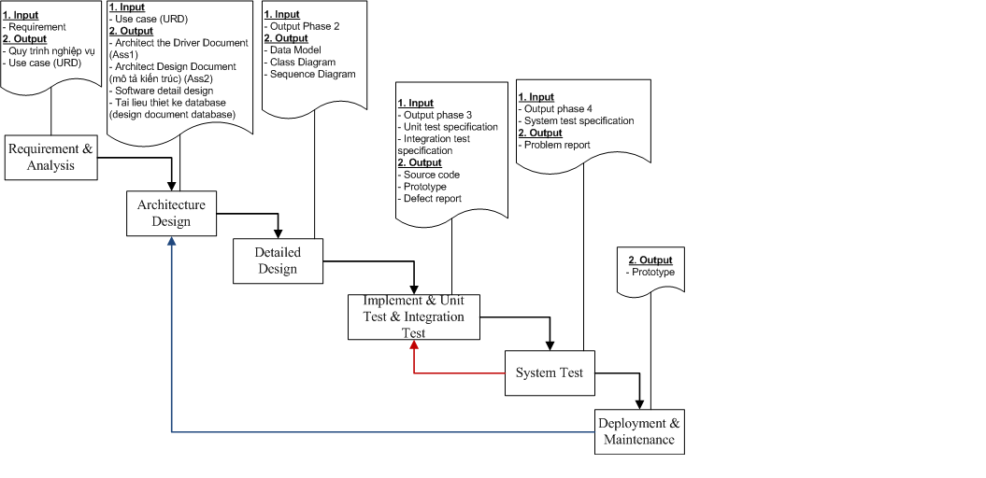
Figure 1-Team Process

Role assignments in the ACDM
No. | Role | Name | Description
1. | Managing Engineering | Le Thi Bich Van | The managing engineer will plan, coordinate, track, and direct the overall activities of the design team.  She is responsible for creating and maintaining the programmatic plans and schedules in both the period of uncertainty and the period of certainty
2. | Chief Architect | Dang Huy Son  Do Minh Tam | The chief architect is responsible for overall system design
3. | Chief Scientist | Le Thi Bich Van
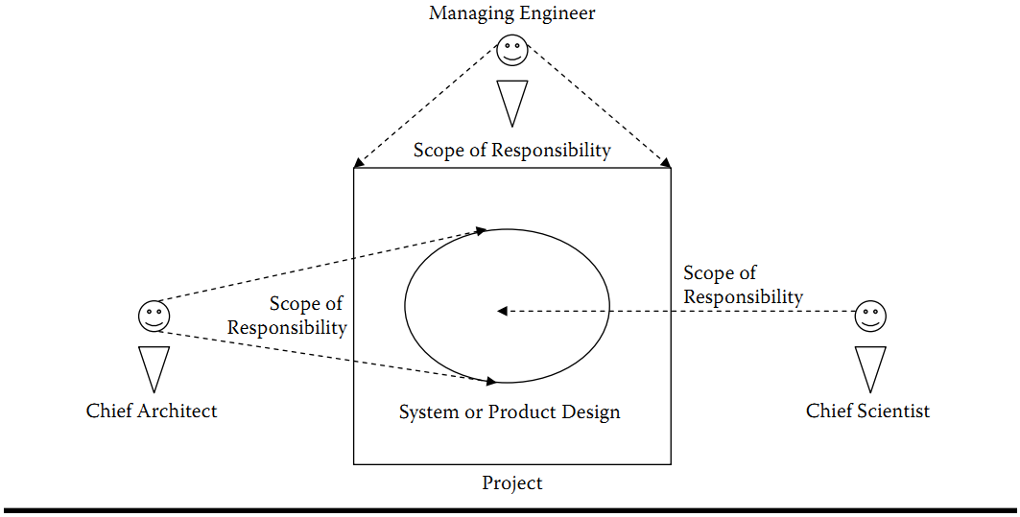
Figure 2 - Representation of the relationships among the managing engineer, chief architect, and chief scientist with respect to the project and system/product design
4. | Support Engineer | Do Minh Tam | The support engineer is responsible for setting up and maintaining the design team’s support tools and environments.  He may also be responsible for the system or  product infrastructure or environment
5. | Requirement Engineer | Le Thi Bich Van | The requirements engineer leads the effort to gather and document the architectural drivers  She will also help to manage the change and evolution of the architectural drivers
6. | Quality Process Engineer | Le Dinh Thach Huyen | The quality process engineer ensures that ACDM and other defined processes are followed as prescribed to ascertain project quality goals are met.
7. | Production Engineer | Le Dinh Thach Huyen  Dang Huy Son  Do Minh Tam  Nguyen Trung Tin  Le Thi Bich Van | These are team members whose focus is on detailed design, implementation of the architectural elements, and integration of the elements to compose the  system.
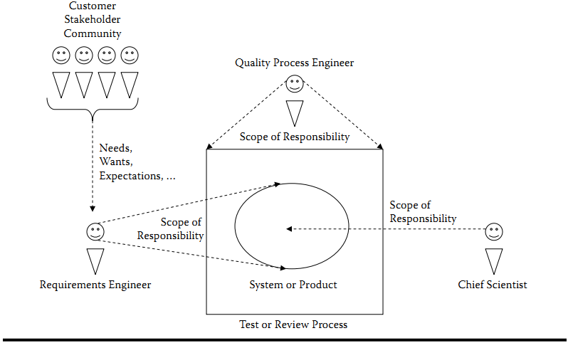
Figure 3 - Representation of the relationships among the quality process engineer, requirement engineer, and chief scientist with respect to system/ product test
Table 2 - Role Assignments in the ACDM

ACDM - Architecture Centric Design Method

Define and Key goals of ACDM
ACDM is a scaleable method for designing the architecture of a software intensive system with a product focus that uses the architecture to complement organizational development and implementation processes activities.
Key goal of ACDM: is intended to be a design framework for:
- Eliciting, analyzing and organizing architectural drivers
- Guiding the design and its documentation
- Evaluating designs
- Guiding experimentation and iterative refinement the design to mitigate risk
- Using the architecture to plan and track system or product construction

ACDM Stages
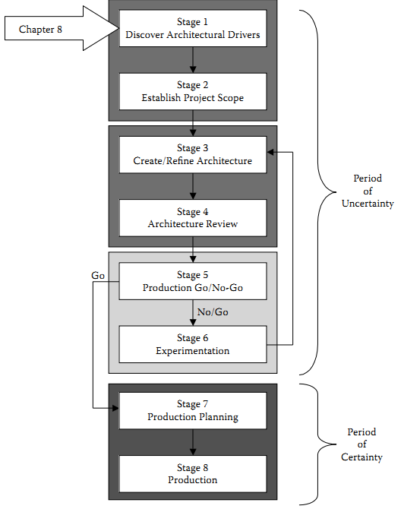

Figure 4 - ACDM Stages

Using ACDM with Software Development Frameworks – Waterfall
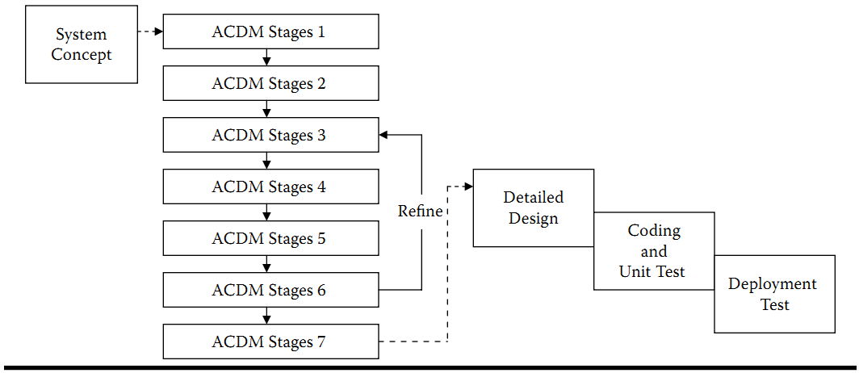
Figure 5 - ACDM and the waterfall model
- Schedule
K15T1-Team1-SmartMartSystem-ScheduleRework-2007

Requirement Document
- Architecture Drivers Document
- Architecture Design Document
- Source code (Prototype)
- Tool
We use Microsoft Project 2010 to define Design Schedule and Microsoft Word 2003 to define Master Design Plan

